Order No: 120 of 2025
Dated: 18-10-2025

Subject: Assignment of Charge for Managing the Administration/Office Inventory and Indent/Stock Registers.

It is hereby ordered that Ms. Ruksana Sultan, Junior Assistant, is hereby assigned the charge of managing the Office Inventory and Indent/Stock Registers of the office/Administration Section with immediate effect. Consequently, Mr. Suhail Sultan stands relieved of these responsibilities.
All concerned are requested to extend their full cooperation to Ms. Ruksana Sultan to ensure the smooth discharge of her duties.
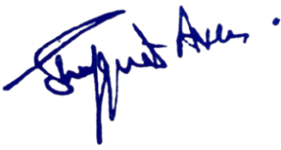

No: No: KGP/Estt/2025/1407 D Dated:18-10-2025
Dr. Shafquat Ara
Principal
Kashmir Govt.Polytechnic College Srinagar
Copy to the:
- Concerned for information and compliance.

